**Homework 6: Problem # 2**

Department of Mechanical and Aerospace Engineering

University of California, San Diego

MAE 150

Lawrence Custodio

A08739279

27 February 2013

Problem: Creo Pro Tutorial (ProE)

Lesson 1: Grip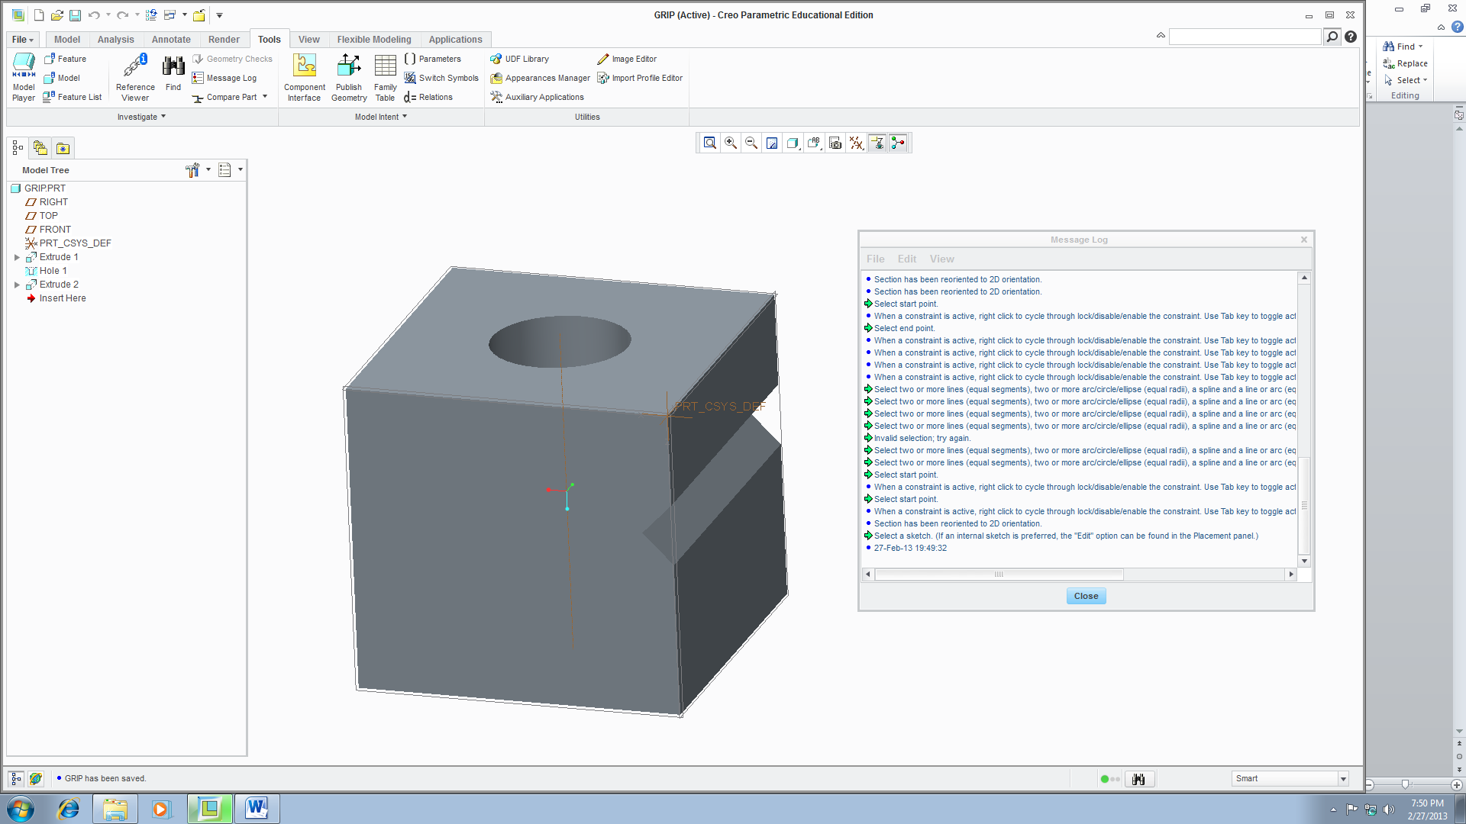

Lesson 2: Pin_A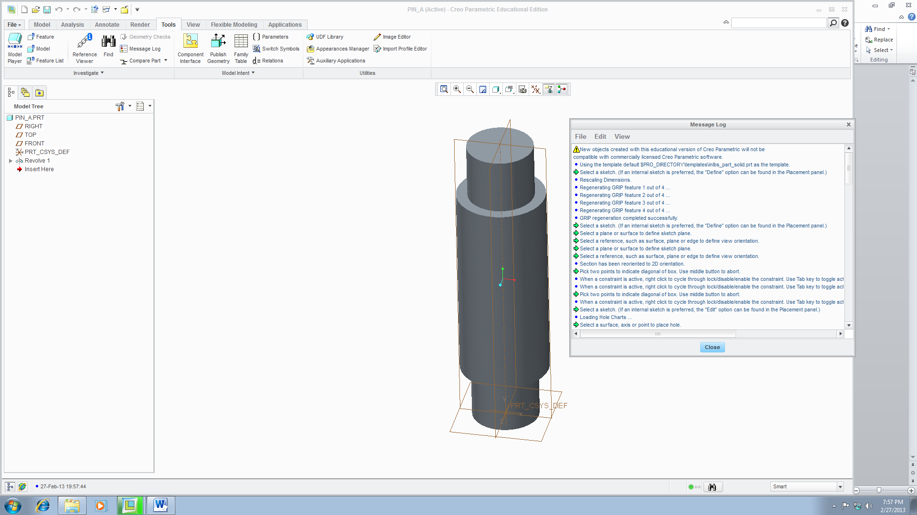

Lesson 3: Hinge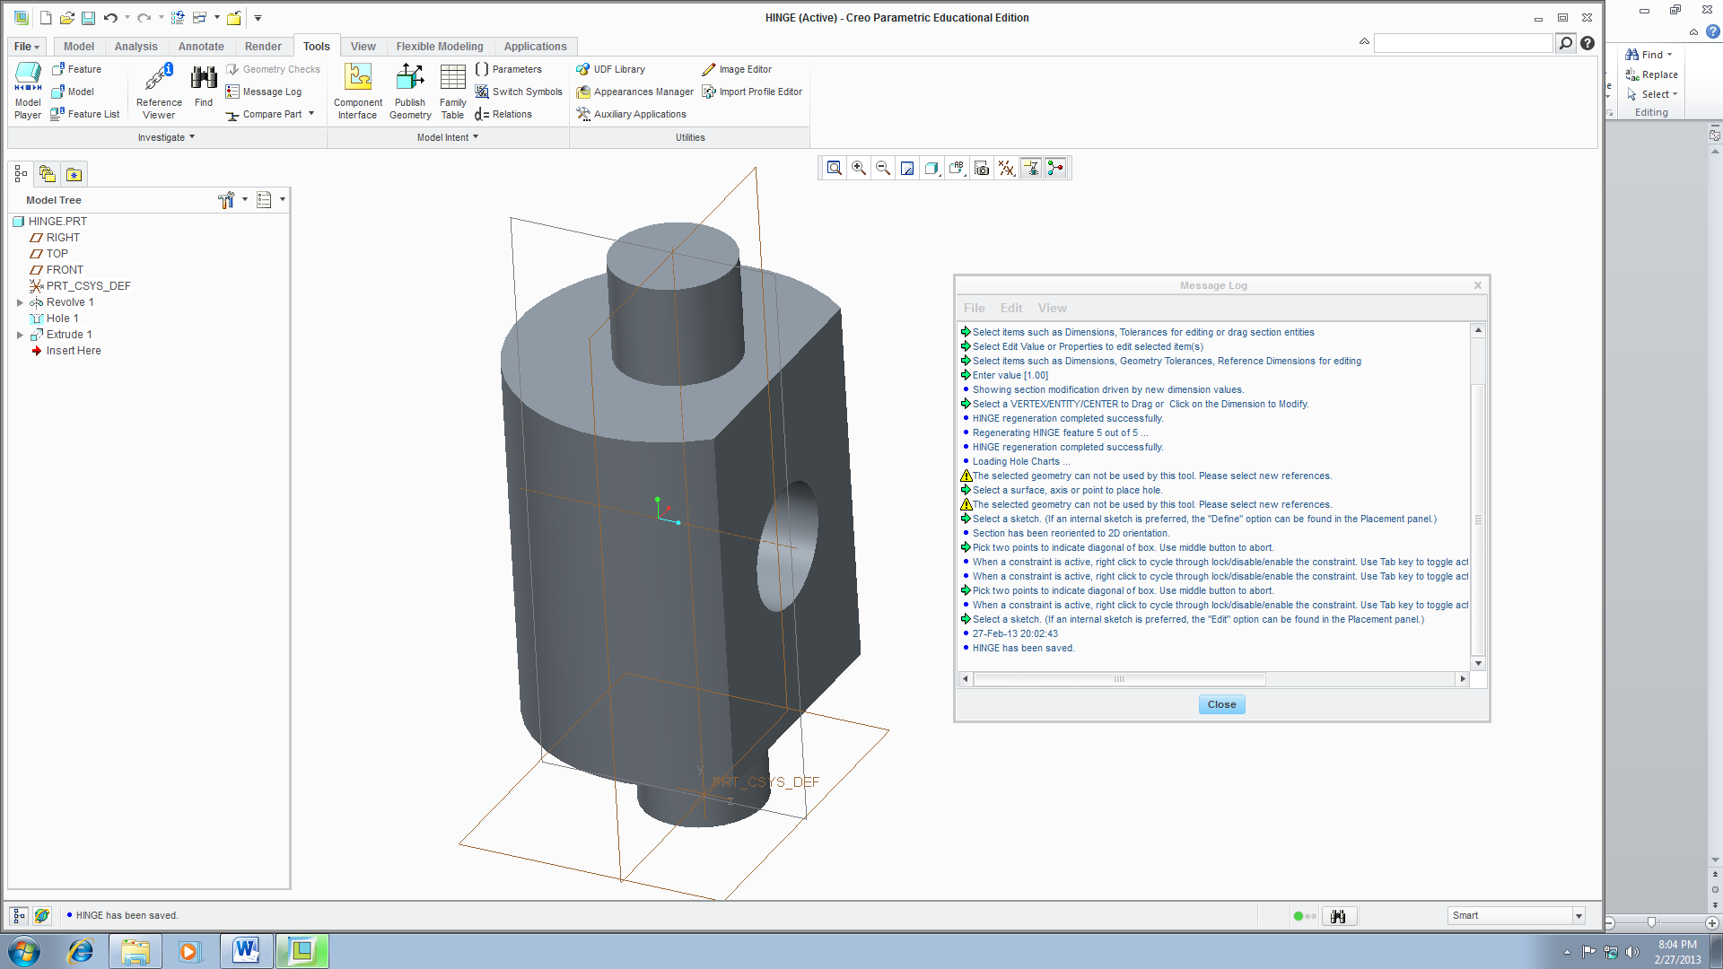

Lesson 4: Brace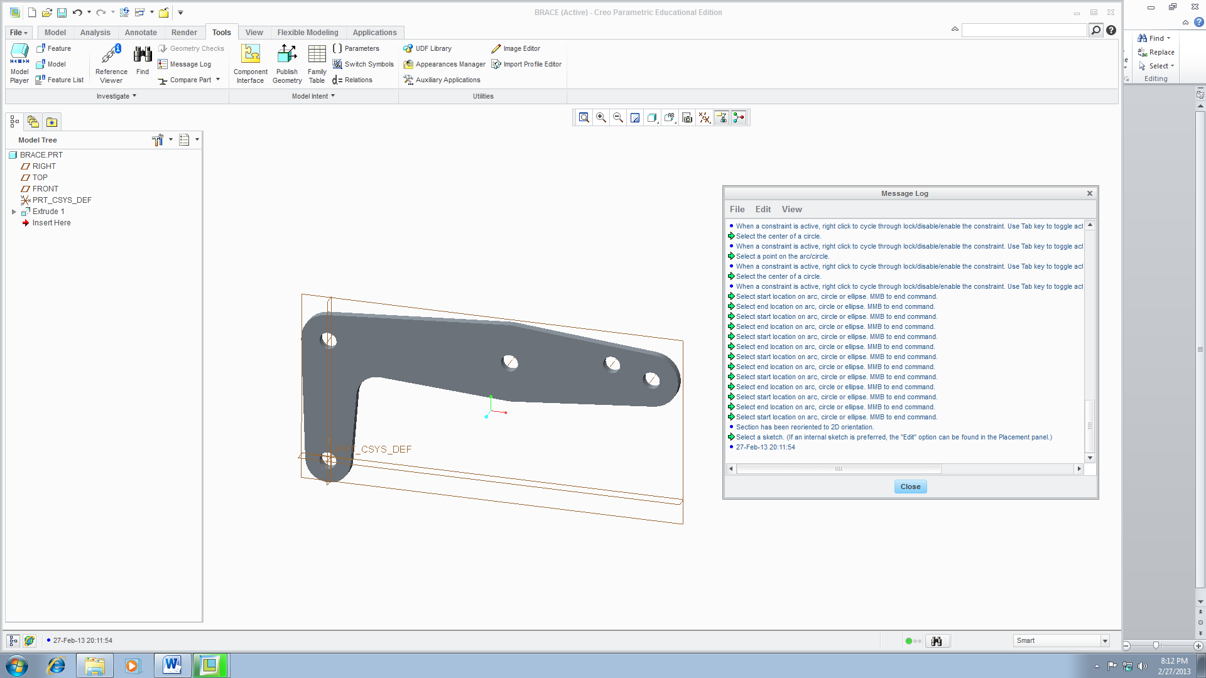

Lesson 5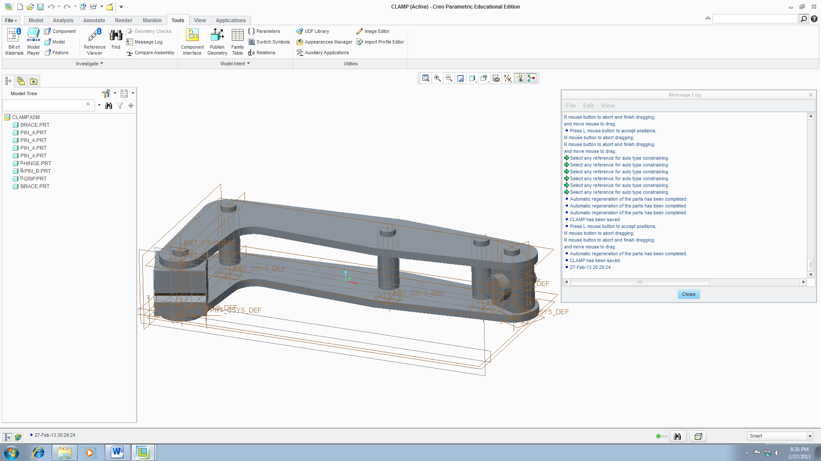

Appendix: Message Logs  
Lesson 1: Grip

New objects created with this educational version of Creo Parametric will not be

compatible with commercially licensed Creo Parametric software.

Using the template default $PRO_DIRECTORY\templates\inlbs_part_solid.prt as the template.

Select a sketch. (If an internal sketch is preferred, the "Define" option can be found in the Placement panel.)

Rescaling Dimensions.

Regenerating GRIP feature 1 out of 4 ...

Regenerating GRIP feature 2 out of 4 ...

Regenerating GRIP feature 3 out of 4 ...

Regenerating GRIP feature 4 out of 4 ...

GRIP regeneration completed successfully.

Select a sketch. (If an internal sketch is preferred, the "Define" option can be found in the Placement panel.)

Select a plane or surface to define sketch plane.

Select a reference, such as surface, plane or edge to define view orientation.

Select a plane or surface to define sketch plane.

Select a reference, such as surface, plane or edge to define view orientation.

Section has been reoriented to 2D orientation.

Pick two points to indicate diagonal of box. Use middle button to abort.

When a constraint is active, right click to cycle through lock/disable/enable the constraint. Use Tab key to toggle active constraint. Press and hold Shift to disable snapping to new constraints.

When a constraint is active, right click to cycle through lock/disable/enable the constraint. Use Tab key to toggle active constraint. Press and hold Shift to disable snapping to new constraints.

Pick two points to indicate diagonal of box. Use middle button to abort.

When a constraint is active, right click to cycle through lock/disable/enable the constraint. Use Tab key to toggle active constraint. Press and hold Shift to disable snapping to new constraints.

…

When a constraint is active, right click to cycle through lock/disable/enable the constraint. Use Tab key to toggle active constraint. Press and hold Shift to disable snapping to new constraints.

Select end point.

When a constraint is active, right click to cycle through lock/disable/enable the constraint. Use Tab key to toggle active constraint. Press and hold Shift to disable snapping to new constraints.

When a constraint is active, right click to cycle through lock/disable/enable the constraint. Use Tab key to toggle active constraint. Press and hold Shift to disable snapping to new constraints.

When a constraint is active, right click to cycle through lock/disable/enable the constraint. Use Tab key to toggle active constraint. Press and hold Shift to disable snapping to new constraints.

When a constraint is active, right click to cycle through lock/disable/enable the constraint. Use Tab key to toggle active constraint. Press and hold Shift to disable snapping to new constraints.

Select two or more lines (equal segments), two or more arc/circle/ellipse (equal radii), a spline and a line or arc (equal curvature), two or more linear/angular dimensions (equal dimension).

Select two or more lines (equal segments), two or more arc/circle/ellipse (equal radii), a spline and a line or arc (equal curvature), two or more linear/angular dimensions (equal dimension).

Select two or more lines (equal segments), two or more arc/circle/ellipse (equal radii), a spline and a line or arc (equal curvature), two or more linear/angular dimensions (equal dimension).

Select two or more lines (equal segments), two or more arc/circle/ellipse (equal radii), a spline and a line or arc (equal curvature), two or more linear/angular dimensions (equal dimension).

Invalid selection; try again.

Select two or more lines (equal segments), two or more arc/circle/ellipse (equal radii), a spline and a line or arc (equal curvature), two or more linear/angular dimensions (equal dimension).

Select two or more lines (equal segments), two or more arc/circle/ellipse (equal radii), a spline and a line or arc (equal curvature), two or more linear/angular dimensions (equal dimension).

Select start point.

When a constraint is active, right click to cycle through lock/disable/enable the constraint. Use Tab key to toggle active constraint. Press and hold Shift to disable snapping to new constraints.

Select start point.

When a constraint is active, right click to cycle through lock/disable/enable the constraint. Use Tab key to toggle active constraint. Press and hold Shift to disable snapping to new constraints.

Section has been reoriented to 2D orientation.

Select a sketch. (If an internal sketch is preferred, the "Edit" option can be found in the Placement panel.)

27-Feb-13 19:49:32

Lesson 2: Pin_A

New objects created with this educational version of Creo Parametric will not be

compatible with commercially licensed Creo Parametric software.

Using the template default $PRO_DIRECTORY\templates\inlbs_part_solid.prt as the template.

Select a sketch. (If an internal sketch is preferred, the "Define" option can be found in the Placement panel.)

Rescaling Dimensions.

Regenerating GRIP feature 1 out of 4 ...

Regenerating GRIP feature 2 out of 4 ...

Regenerating GRIP feature 3 out of 4 ...

Regenerating GRIP feature 4 out of 4 ...

GRIP regeneration completed successfully.

Select a sketch. (If an internal sketch is preferred, the "Define" option can be found in the Placement panel.)

Select a plane or surface to define sketch plane.

Select a reference, such as surface, plane or edge to define view orientation.

Select a plane or surface to define sketch plane.

Select a reference, such as surface, plane or edge to define view orientation.

Section has been reoriented to 2D orientation.

Pick two points to indicate diagonal of box. Use middle button to abort.

When a constraint is active, right click to cycle through lock/disable/enable the constraint. Use Tab key to toggle active constraint. Press and hold Shift to disable snapping to new constraints.

When a constraint is active, right click to cycle through lock/disable/enable the constraint. Use Tab key to toggle active constraint. Press and hold Shift to disable snapping to new constraints.

Pick two points to indicate diagonal of box. Use middle button to abort.

When a constraint is active, right click to cycle through lock/disable/enable the constraint. Use Tab key to toggle active constraint. Press and hold Shift to disable snapping to new constraints.

…

Select two or more lines (equal segments), two or more arc/circle/ellipse (equal radii), a spline and a line or arc (equal curvature), two or more linear/angular dimensions (equal dimension).

Invalid selection; try again.

Select two or more lines (equal segments), two or more arc/circle/ellipse (equal radii), a spline and a line or arc (equal curvature), two or more linear/angular dimensions (equal dimension).

Invalid selection; try again.

Select two or more lines (equal segments), two or more arc/circle/ellipse (equal radii), a spline and a line or arc (equal curvature), two or more linear/angular dimensions (equal dimension).

Invalid selection; try again.

Select two or more lines (equal segments), two or more arc/circle/ellipse (equal radii), a spline and a line or arc (equal curvature), two or more linear/angular dimensions (equal dimension).

Invalid selection; try again.

Select two or more lines (equal segments), two or more arc/circle/ellipse (equal radii), a spline and a line or arc (equal curvature), two or more linear/angular dimensions (equal dimension).

Invalid selection; try again.

Select two or more lines (equal segments), two or more arc/circle/ellipse (equal radii), a spline and a line or arc (equal curvature), two or more linear/angular dimensions (equal dimension).

Select two or more lines (equal segments), two or more arc/circle/ellipse (equal radii), a spline and a line or arc (equal curvature), two or more linear/angular dimensions (equal dimension).

Select start point.

When a constraint is active, right click to cycle through lock/disable/enable the constraint. Use Tab key to toggle active constraint. Press and hold Shift to disable snapping to new constraints.

Select end point.

When a constraint is active, right click to cycle through lock/disable/enable the constraint. Use Tab key to toggle active constraint. Press and hold Shift to disable snapping to new constraints.

Select start point.

When a constraint is active, right click to cycle through lock/disable/enable the constraint. Use Tab key to toggle active constraint. Press and hold Shift to disable snapping to new constraints.

Select a Straight Curve or a edge, axis, or axis of coordinate system to specify axis of revolution.

27-Feb-13 19:55:31

Lesson 3: Hinge

New objects created with this educational version of Creo Parametric will not be

compatible with commercially licensed Creo Parametric software.

Select items such as Dimensions, Tolerances for editing or drag section entities

Part 'HINGE' not changed since last regen.

Select items such as Dimensions, Tolerances for editing or drag section entities

Select Edit Value or Properties to edit selected item(s)

Select items such as Dimensions, Geometry Tolerances, Reference Dimensions for editing

Enter value [1.00]

Showing section modification driven by new dimension values.

Select a VERTEX/ENTITY/CENTER to Drag or Click on the Dimension to Modify.

HINGE regeneration completed successfully.

Regenerating HINGE feature 5 out of 5 ...

HINGE regeneration completed successfully.

Loading Hole Charts ...

The selected geometry can not be used by this tool. Please select new references.

Select a surface, axis or point to place hole.

The selected geometry can not be used by this tool. Please select new references.

Select a sketch. (If an internal sketch is preferred, the "Define" option can be found in the Placement panel.)

Section has been reoriented to 2D orientation.

Pick two points to indicate diagonal of box. Use middle button to abort.

When a constraint is active, right click to cycle through lock/disable/enable the constraint. Use Tab key to toggle active constraint. Press and hold Shift to disable snapping to new constraints.

When a constraint is active, right click to cycle through lock/disable/enable the constraint. Use Tab key to toggle active constraint. Press and hold Shift to disable snapping to new constraints.

Pick two points to indicate diagonal of box. Use middle button to abort.

When a constraint is active, right click to cycle through lock/disable/enable the constraint. Use Tab key to toggle active constraint. Press and hold Shift to disable snapping to new constraints.

Select a sketch. (If an internal sketch is preferred, the "Edit" option can be found in the Placement panel.)

27-Feb-13 20:02:43

HINGE has been saved.

Lesson 4: Brace

Using the template default $PRO_DIRECTORY\templates\inlbs_part_solid.prt as the template.

Base window cannot be closed.

Rescaling Dimensions.

Regenerating BRACE feature 1 out of 4 ...

Regenerating BRACE feature 2 out of 4 ...

Regenerating BRACE feature 3 out of 4 ...

Regenerating BRACE feature 4 out of 4 ...

BRACE regeneration completed successfully.

Select a sketch. (If an internal sketch is preferred, the "Define" option can be found in the Placement panel.)

Select a plane or surface to define sketch plane.

Select a reference, such as surface, plane or edge to define view orientation.

Section has been reoriented to 2D orientation.

Select the center of a circle.

When a constraint is active, right click to cycle through lock/disable/enable the constraint. Use Tab key to toggle active constraint. Press and hold Shift to disable snapping to new constraints.

Select a point on the arc/circle.

When a constraint is active, right click to cycle through lock/disable/enable the constraint. Use Tab key to toggle active constraint. Press and hold Shift to disable snapping to new constraints.

Select the center of a circle.

When a constraint is active, right click to cycle through lock/disable/enable the constraint. Use Tab key to toggle active constraint. Press and hold Shift to disable snapping to new constraints.

Select a point on the arc/circle.

When a constraint is active, right click to cycle through lock/disable/enable the constraint. Use Tab key to toggle active constraint. Press and hold Shift to disable snapping to new constraints.

…

When a constraint is active, right click to cycle through lock/disable/enable the constraint. Use Tab key to toggle active constraint. Press and hold Shift to disable snapping to new constraints.

Select the center of a circle.

When a constraint is active, right click to cycle through lock/disable/enable the constraint. Use Tab key to toggle active constraint. Press and hold Shift to disable snapping to new constraints.

Select start location on arc, circle or ellipse. MMB to end command.

Select end location on arc, circle or ellipse. MMB to end command.

Select start location on arc, circle or ellipse. MMB to end command.

Select end location on arc, circle or ellipse. MMB to end command.

Select start location on arc, circle or ellipse. MMB to end command.

Select end location on arc, circle or ellipse. MMB to end command.

Select start location on arc, circle or ellipse. MMB to end command.

Select end location on arc, circle or ellipse. MMB to end command.

Select start location on arc, circle or ellipse. MMB to end command.

Select end location on arc, circle or ellipse. MMB to end command.

Select start location on arc, circle or ellipse. MMB to end command.

Select end location on arc, circle or ellipse. MMB to end command.

Select start location on arc, circle or ellipse. MMB to end command.

Section has been reoriented to 2D orientation.

Select a sketch. (If an internal sketch is preferred, the "Edit" option can be found in the Placement panel.)

27-Feb-13 20:11:54

BRACE has been saved.

Lesson 5: Assembly

New objects created with this educational version of Creo Parametric will not be

compatible with commercially licensed Creo Parametric software.

Select items such as Dimensions, Tolerances for editing or drag section entities

Part 'HINGE' not changed since last regen.

Select items such as Dimensions, Tolerances for editing or drag section entities

Select Edit Value or Properties to edit selected item(s)

Select items such as Dimensions, Geometry Tolerances, Reference Dimensions for editing

Enter value [1.00]

Showing section modification driven by new dimension values.

Select a VERTEX/ENTITY/CENTER to Drag or Click on the Dimension to Modify.

HINGE regeneration completed successfully.

Regenerating HINGE feature 5 out of 5 ...

HINGE regeneration completed successfully.

Loading Hole Charts ...

The selected geometry can not be used by this tool. Please select new references.

Select a surface, axis or point to place hole.

The selected geometry can not be used by this tool. Please select new references.

Select a sketch. (If an internal sketch is preferred, the "Define" option can be found in the Placement panel.)

Section has been reoriented to 2D orientation.

Pick two points to indicate diagonal of box. Use middle button to abort.

When a constraint is active, right click to cycle through lock/disable/enable the constraint. Use Tab key to toggle active constraint. Press and hold Shift to disable snapping to new constraints.

…

M mouse button to abort dragging;

R mouse button to abort and finish dragging;

and move mouse to drag.

Select any reference for auto type constraining.

Select any reference for auto type constraining.

Select any reference for auto type constraining.

Select any reference for auto type constraining.

Select any reference for auto type constraining.

Select any reference for auto type constraining.

Automatic regeneration of the parts has been completed.

Automatic regeneration of the parts has been completed.

Automatic regeneration of the parts has been completed.

CLAMP has been saved.

Press L mouse button to accept positions;

M mouse button to abort dragging;

R mouse button to abort and finish dragging;

and move mouse to drag.

Automatic regeneration of the parts has been completed.

CLAMP has been saved.

27-Feb-13 20:29:24